***Dt : 20/4/2022***

***FSJD - (5 Months)***

***CJ - 55 - 60 Sessions***

***=============================================================***

***Java : language***

***Process of Learning Language:***

***step-1 : Alphabets***

***step-2 : Grammer***

***step-3 : Construction rules***

***Note:***

***=>Every Language will have its own Alphabets,Grammer and***

***Construction rules***

***===========================================================***

***Java:***

***part-1 : CoreJava***

***part-2 : AdvJava***

***part-1 : CoreJava:***

***(i)Programming Components(Java Alphabets)***

***(ii)Programming Concepts***

***(iii)Object Oriented Programming features.***

***(i)Programming Components(Java Alphabets)***

***1.Variables***

***2.Methods***

***3.Blocks***

***4.Constructors***

***5.Classes***

***6.Interfaces***

***7.AbstractClasses***

***(ii)Programming Concepts***

***1.Object Oriented programming***

***2.Exception Handling process***

***3.Multi-Threading process***

***4.Java Collection Framework(JCF)***

***=>DataStructures in Java***

***5.Files in Java***

***6.Networking in Java***

***(iii)Object Oriented Programming features.***

***1.Class***

***2.Object***

***3.Abstraction***

***4.Encapsulation***

***5.PolyMorphism***

***6.Inheritance***

***Note:***

***=>Using CoreJava Alphabets and Concepts we can develop StandAlone***

***applications.***

***faq:***

***define StandAlone Applications?***

***=>The applications which are installed in one computer performs***

***actions in the same computer are known as StandAlone applications***

***or DeskTop applications or Windows Aplications.***

***Note:***

***=>According to developed StandAlone applications means,***

***No HTML input***

***No Server Environment***

***No Database Storage***

***==============================================================***

***Join Us On Telegram : https://t.me/javalatestupdates***

***Dt : 21/4/2022***

***part-2 : AdvJava***

***=>AdvJava provides the following three technologies to construct***

***WebApplications:***

***(a)JDBC***

***(b)Servlet***

***(c)JSP***

***Diagram:***

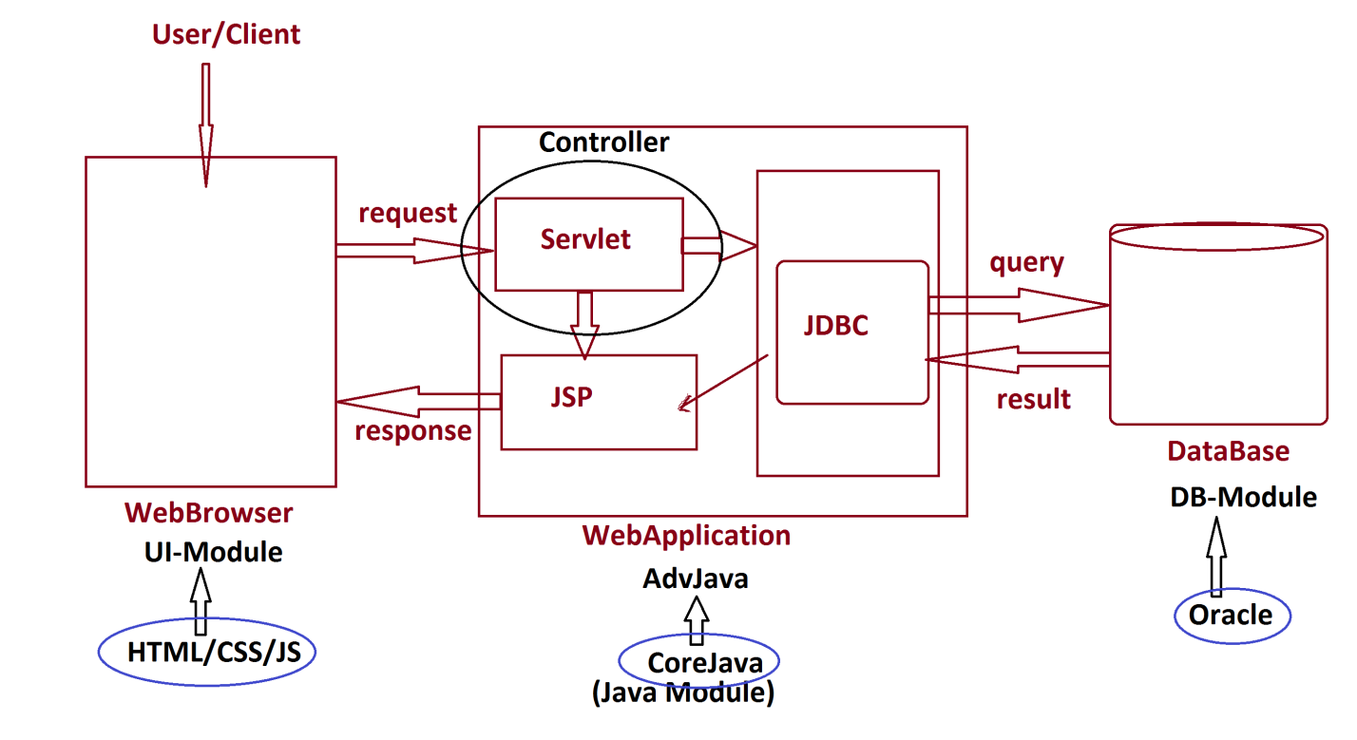

***(a)JDBC:***

***=>JDBC stands for Java DataBase Connectivity and which is used to***

***interact with DataBase.***

***(b)Servlet:***

***=>Servlet means 'Server program' and which is used to accept the***

***request from users through WebBrowser.***

***(c)JSP:***

***=>JSP stands for 'Java Server page' and which is response from***

***WebApplication.***

***faq:***

***define Web Applications?***

***=>The applications which are executed in WebEnvironment or***

***Internet Environment are known as WebApplications.***

***=============================================================***

***Dt : 22/4/20221***

***Programming Module***

***(i)CoreJava - StandAlone application development***

***(ii)AdvJava - WebApplication development***

***(iii)Spring and WebServices - Enterprise Applications***

***(Project)***

***faq:***

***wt is the diff b/w***

***(i)Language***

***(ii)Technology***

***(iii)Framework***

***(i)Language:***

***=>Language will provide Programming components and Concepts used in***

***constructing applications.***

***Ex:***

***CoreJava***

***(ii)Technology:***

***=>The process of applying the knowledge to realtime world application***

***development,is known as Technology.***

***Ex:***

***AdvJava***

***(iii)Framework:***

***=>The structure which is ready constructed and available for application***

***development is known as Framework.***

***Ex:***

***Spring***

***WebService***

***-------------------------------------------------------------***

***faq:***

***define Enterprise Applications?***

***=>The application which is executing in distributed environment and***

***depending on the features like 'Security','Load balancing' and***

***'Clustering' is known as Enterprise application or Enterprise distributed***

***application.***

***================================================================***